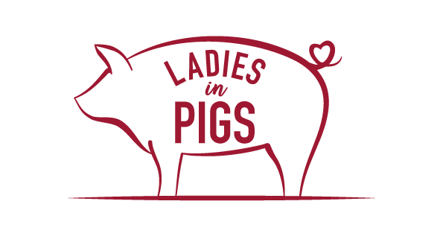

Ladies in Pigs school engagement
Teacher pack - KS1/2

Please find below curriculum links below that are hit through our in-school and virtual engagement events with the children from your school. These are clearly set out in curriculum areas and in a wording that could be copied and pasted into your planning documents. All our work is linked to STEM and cross curricular aims are also met.
We look forward to you booking a session with your school either with a virtual taster session and/or a face to face full day of activities when it is safe to do so.

Debbie
Chairwoman – Ladies in Pigs

Key Stage 1
Science

- asking simple questions and recognising that they can be answered in different ways
- observing closely, using simple equipment
- performing simple tests
- identifying and classifying
- using their observations and ideas to suggest answers to questions
- identify and name a variety of common animals
- observe changes across the four seasons ▪ observe and describe weather associated with the seasons and how day length varies.

Technology

- use technology purposefully to create, organise, store, manipulate and retrieve digital content
- recognise common uses of information technology beyond school

English

- Being introduced to non-fiction texts that are structured in different ways
- Discussing and clarifying the meanings of words, linking new meanings to known vocabulary
- Checking that the text makes sense to them as they read and correcting inaccurate reading making inferences based on what is being said and done
- Answering and asking questions and following verbal instructions.
- Reading, using and understanding instructional writing.

PHSE

- Learn about some of the things that keep our bodies healthy (physical activity, sleep, rest, healthy food)
- what is meant by a healthy lifestyle?
- how to maintain physical, mental and emotional health and wellbeing

Geography

- identify seasonal and daily weather patterns in the United Kingdom use basic geographical vocabulary to refer to:
- key physical features, including: beach, cliff, coast, forest, hill, mountain, sea, ocean, river, soil, valley, vegetation, season and weather
- key human features, including: city, town, village, factory, farm, house, office, port, harbour and shop
D & T

- use the basic principles of a healthy and varied diet to prepare dishes
- understand where food comes from.
Maths
- Use measures – standard and non-standard
- Complete addition problems in a written form
- Complete data collection and organise results

Key Stage 2
Science

- identifying differences, similarities or changes related to simple scientific ideas and processes
- asking relevant questions and using different types of scientific enquiries to answer them
- identifying differences, similarities or changes related to simple scientific ideas and processes
- describe how animals obtain their food from plants and other animals, using the idea of a simple food chain, and identify and name different sources of food
- identify that animals, including humans, need the right types and amount of nutrition, and that they cannot make their own food; they get nutrition from what they eat
- recognise that living things produce offspring of the same kind, but normally offspring vary and are not identical to their parents
Technology

- understand computer networks including the internet; how they can provide multiple services, such as the world wide web; and the opportunities they offer for communication and collaboration
- use search technologies effectively, appreciate how results are selected and ranked, and be discerning in evaluating digital content
English

- Being introduced to non-fiction texts that are structured in different ways
- Discussing and clarifying the meanings of words, linking new meanings to known vocabulary
- Checking that the text makes sense to them as they read and correcting inaccurate reading making inferences based on what is being said and done
- Answering and asking questions
- read further exception words, noting the unusual correspondences between spelling and sound, and where these occur in the word.
- apply their growing knowledge of root words, prefixes and suffixes (morphology and etymology), as listed in English Appendix 1, both to read aloud and to understand the meaning of new words that they meet.
- listen and respond appropriately to adults and their peers
- ask relevant questions to extend their understanding and knowledge
- maintain attention and participate actively in collaborative conversations, staying on topic and initiating and responding to comments
- speak audibly and fluently with an increasing command of Standard English
- gain, maintain and monitor the interest of the listener(s)

Maths

- compare and sort common 2-D and 3-D shapes and everyday objects.
- compare and sequence intervals of time
- choose and use appropriate standard units to estimate and measure length/height in any direction (m/cm); mass (kg/g); temperature (°C); capacity (litres/ml) to the nearest appropriate unit, using rulers, scales, thermometers and measuring vessels
- compare, describe and solve practical problems for: lengths and heights] capacity and volume and time
- Convert between different units of measure
- convert between different units of metric measure
- understand and use approximate equivalences between metric units and common imperial units such as inches, pounds and pints

PHSE

- how to manage risks to physical and emotional health and wellbeing
- how to make informed choices (including recognising that choices can have positive, neutral and negative consequences) and to begin to understand the concept of a ‘balanced lifestyle’. To recognise opportunities and develop the skills to make their own choices about food, understanding what might influence their choices and the benefits of eating a balanced diet
- to differentiate between the terms, ‘risk’, ‘danger’ and ‘hazard’
- that bacteria and viruses can affect health and that following simple routines can reduce their spread.
- to respect diversity and equality and how to be a productive member of a diverse community
- about the importance of respecting and protecting the environment

Geography

- name and locate counties and cities of the United Kingdom, geographical regions and their identifying human and physical characteristics, key topographical features (including hills, mountains, coasts and rivers), and land-use patterns; and understand how some of these aspects have changed over time

D & T

- understand and apply the principles of a healthy and varied diet
- prepare and cook a variety of predominantly savoury dishes using a range of cooking techniques
- understand seasonality, and know where and how a variety of ingredients are grown, reared, caught and processed

