Priscilla the Pig – tell us a story!
Use the plan below to tell us a story about Priscilla
Beginning
Character

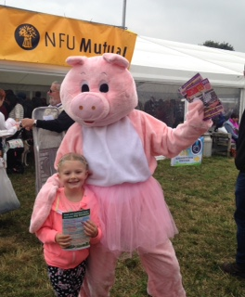
Middle
Ending
Setting

