Priscilla the Pig – tell us a story!
Use the plan below to tell us a story about Priscilla
Beginning

Who are your characters?
Characters

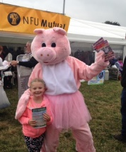
What WOW words can you use?

What connectives can you use?
Ending
Sorting out the problem
Middle
Setting

