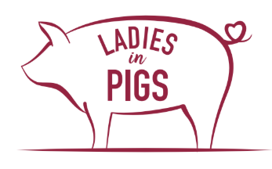
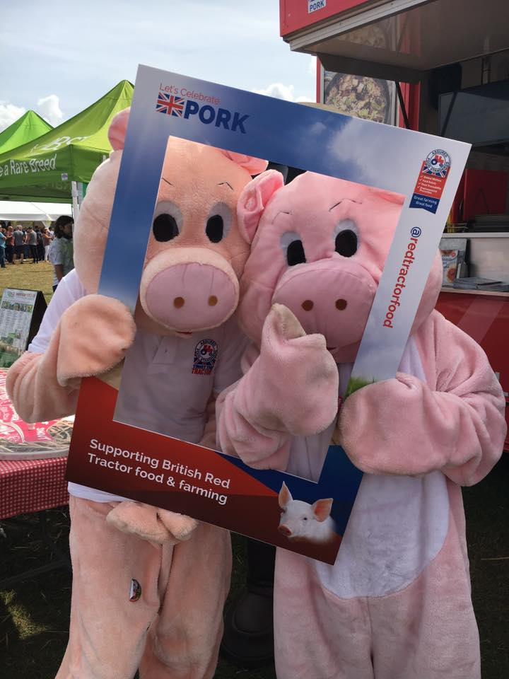

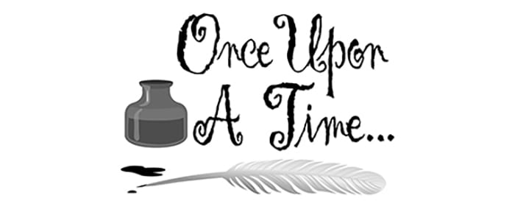

Story writing Competition – terms
We have provided story plans or boards that are suitable for all primary children to enter our story writing competition.
Here are the terms of the competition.
- There will be a prize for the winning entry from Key Stage 1 (4-7) and Key Stage 2 (8-11). Each winner will receive a bag with lots of surprises and a copy of their story in a real book!
- All entries need to have the child’s first name, age and school on it
- Entries need to be made via email to ladiesinpigs@gmail.com
- Entries close on Friday 26th March.
- The winners will be announced on Monday 12th April and notified via email.
- By entering the competition permission is given to share details of the entrants.

