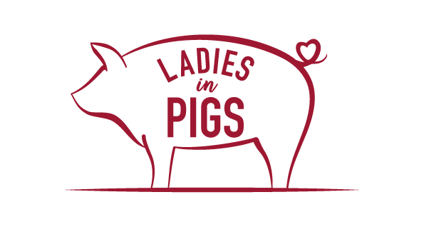
KS1/2 Teacher Notes

Thank you for inviting Ladies in Pigs into your school, we are excited about meeting you all and especially the children.

We have 6 activities designed for your children which you will have the opportunity to do during the day, we also have extension activities too.

We are in the process of converting paper-based activities into interactive ones to save on printing and paper! These will be sent over via email prior to the event with access details. These will be clearly labelled as KS1 or KS2 and the activities are designed so that you can use your discretion to differentiate where necessary, as you know your children best!

Hopefully, in addition to the hands-on cooking session, you should be able to complete 3 or more of these activities within the day. We would really love to see completed work, particularly from the Design It! Make It! and Create It! sessions. You can either save to the interactive lesson, or photographs/videos of any activities can be taken and emailed to ladiesinpigs@gmail.com in line with your school’s relevant policy.

Please find below an overview of the sessions:

Cook It! – Groups in sizes to suit the school and timetable will join the Ladies in Pigs team to cook a recipe from scratch, learning about food labelling, where food comes from, how to follow recipes etc. There will also be some games to play to reinforce the food labelling and the different parts of the pig.

Create It! - In class, with teacher support, the children will be asked to complete work around recipes that we use at Ladies in Pigs. There will be a variety of activities in each pack.

This session is an opportunity to talk to the children about eating as a family, nutrition, and what nutrients we get from different foods.

The activities are based around a video, the Eatwell plate and a recipe card and encourage creativity, sequencing, comprehension, speaking and listening and much more.

Make it! – In the make it resources you will find an image of a British flag which is made up of different foods which have been produced in the UK as part of the Red Tractor assurance scheme. This will form the basis of this session, and there are a variety of games and activities for each Key stage.

This will give you the opportunity to discuss how the children think that these foods are produced or grown, what type of farm would produce them, what would the production process be?

The children may need white boards to write down as many of the identified foods that they have eaten in the last year. You could collect data that shows who has eaten what out of the foods discussed and create an age-appropriate chart to show the results.

You can also use the blank flag provided for the children to colour or draw in their favourite foods or to just colour in the correct colours.

Describe It! - This activity will require the children to look at 4 different countryside landscapes (which will be provided via an interactive lesson). There are different tasks as part of this that relate to speaking and listening, observation, descriptive writing.

Act It! – In the interactive resources, you will find the links to short films about different farmers. Please watch these with the children, (they are each around 3 mins long so just choose a selection, obviously we would like you to watch the pig one!) encouraging them to listen carefully to what the farmers say about their jobs, their routine - day to day and how passionate they are about getting the best produce to our plates. Their farms are assessed by The Red Tractor scheme every three months by vets, and annually they have all the farm and their paperwork checked, just like OFSTED do in school! You can also talk to the children about the different types of jobs there are in agriculture, and that you do not have to be born on a farm to be a farmer, lots of people enter the industry through colleges or university.

KS1 – The children can take it in turns to “act” as different types of farmers or farm animals that they have seen.

KS2 – in small groups the children can take turns in a “hot seat” playing the part of a farmer and answering questions about what it’s like to be a farmer.

Videos of these would be great!

For KS1 - As a bit of fun to finish, Use the following link to sing along ‘Old Macdonald had a farm’
https://you.tube/dpnUYVezBVw

Design It! –

For KS1 we would like the children to design a ‘Wanted!’ poster for a farmer. In the resources pack we will include some starter ideas of what to include and some images to remind them.

Please do this on an A4 piece of paper or if doing it computer based on a full page.

For KS2 we would love then to design the front cover of the 2022 Pig Issue. Examples of what we have had before will be in the resources pack along with some starter ideas. These can be done by hand or via computer and must be A5 landscape. This is a competition with the winner getting prizes along with their design featuring in the next printed version of the booklet!

And finally!

At the end of the day, we would love it if you can do the poll on the interactive lesson, so that we can get feedback on how the children have enjoyed the day.

We hope that you all have a great day learning about farming and Red Tractor, please ensure that you give one of the ladies any resources at the end of the day.

Thank you!

